ELEMENTARY SCHOOL MEALS PROGRAM
LUNCH ORDER FORM

School’s Name:
Student’s Name:
Grade:
Division:
Teacher:

Allergies / Religious Requests:
- Vegetarian/Fish OK □ Vegetarian/No Fish
- No Pork
- Other: _____________________________________________________

Payment Amount: _______________



September 2019

MONDAY | TUESDAY | WEDNESDAY | THURSDAY | FRIDAY
2  Labor  Day | 3  No District  Lunches | 4  No District  Lunches | 5  No District  Lunches | 6  No District  Lunches
9  Chocolate Milk  Roast Beef Sandwich  Granola Bar  Fruit | 10  Juice  Turkey Sandwich  Yogurt  Veggie & Dip | 11  White Milk  Cream Cheese & Jam Bagel  Cookie  Fruit | 12  Juice  Ham Sandwich  Yogurt  Fruit | 13  Chocolate Milk  Cheese Sandwich  Veggie & Dip  Chips
16  Juice  Roast Beef Sandwich  Pudding  Fruit | 17  White Milk  Egg Sandwich  Cookie  Veggie & Dip | 18  Juice  Turkey Sandwich  Yogurt  Fruit | 19  Chocolate Milk  Pizza Wrap  Granola Bar  Fruit | 20  District  Pro - D  Day
23  Juice  Roast Beef Sandwich  Granola Bar  Fruit | 24  White Milk  Egg Sandwich  Cookie  Veggie & Dip | 25  Juice  Chicken Wrap  Yogurt  Cookie | 26  Chocolate Milk  Ham Sandwich  Bits & Bites  Fruit | 27  Juice  Cheese Sandwich  Yogurt  Veggie & Dip
30  White Milk  Roast Beef Sandwich  Bits & Bites  Fruit |  |  |  | 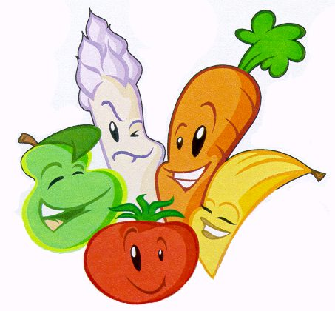
PLEASE NOTE:

- WE DO NOT GUARANTEE A NUT-FREE ENVIRONMENT. ALL OF OUR BREADS AND BAKED GOODS
MAY CONTAIN TRACES OF NUTS.

- MENU SUBJECT TO CHANGE BASED ON AVAILABILITY FROM SUPPLIERS.

- September 2019 Lunches: 15 @ $6.00 = $90.00
- Please pay with your (KEV) school cash on-line account.

- ORDER DUE TO OFFICE BY 9:00 AM, Wednesday September 4, 2019

